1. **[OPTIONAL]** Read chapter #5 ‘Control Statements - Java Selection Statements - Switch’ of ‘Java: The Complete Reference - Herbert Schildt’  
   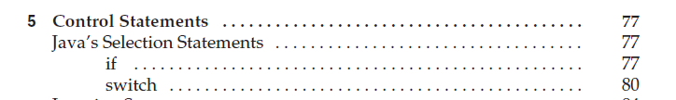
2. Implement console program which will meet the following requirements:
   1. Program is started and user is asked to enter one of possible events:
      1. login
      2. sign_up
      3. terminate_program
      4. main_menu
      5. about_app
   2. Based on user input program prints to console different text. Mapping is below:

| **User Input** | **Console output** |
| --- | --- |
| login | Please, enter your username |
| sign_up | Welcome! |
| terminate_program | Thank you! Good bye! |
| main_menu | Main menu |
| about_app | This app is created by me with support of ®IT-Bulls.com |
| <any other input> | Please, enter one of these values: login, sign_up, terminate_program, main_menu, about_app |